Appendix 1 Creative Snacks

Peanut butter and coconut banana log

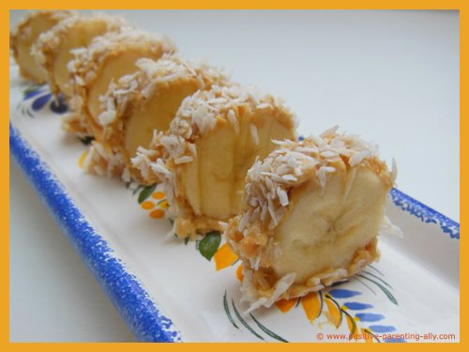

What it is supposed to look like

Elliot, age 4, making a peanut butter and coconut banana log. We didn’t have coconut so used grated apple instead. Elliot found it difficult to spread the peanut butter on the banana but said it was ‘so so yummy’

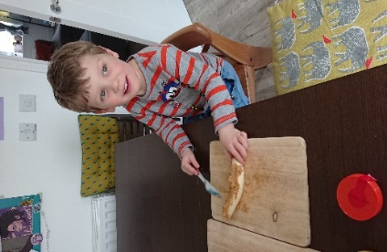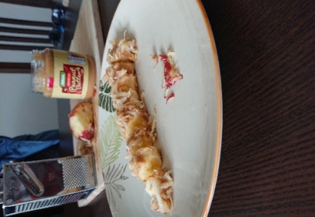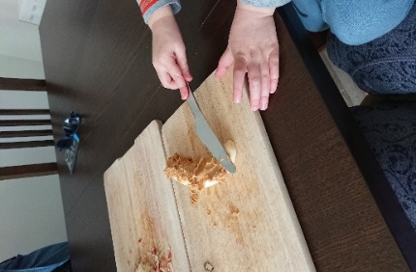

Fruit kebabs

Myles, age 4, makes delicious fruit kebabs

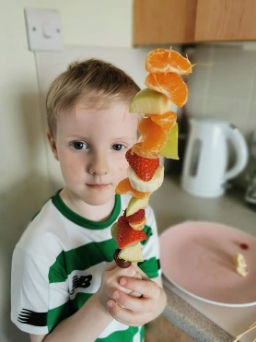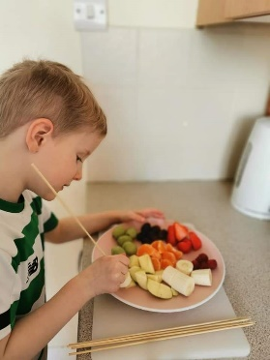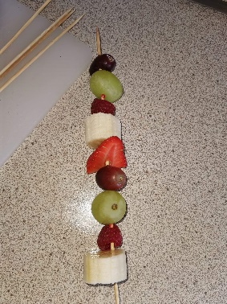

Snack

Snack inspired by a book

The Very Hungry Caterpillar by Eric Carle

Elliot, age 2, prepares his snack

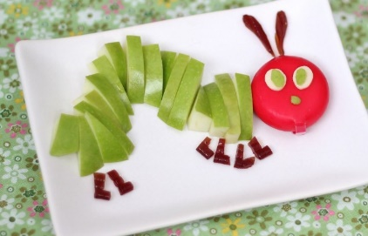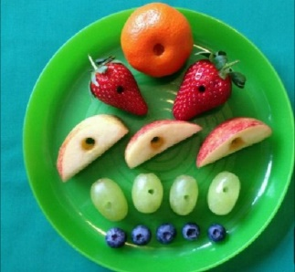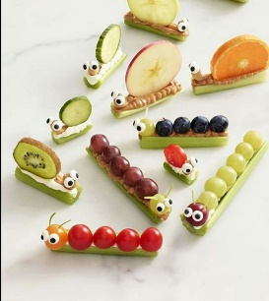

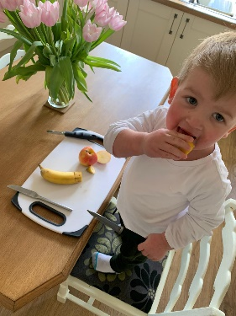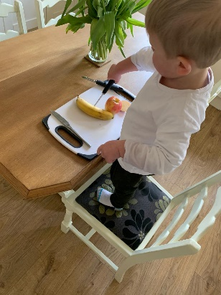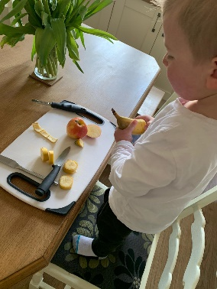

Some snack art to try.

For more ideas visit:

[www.hellowonderful.co](http://www.hellowonderful.co) [www.onelittleproject.com](http://www.onelittleproject.com) [www.lmld.org/food-art-ideas](http://www.lmld.org/food-art-ideas)

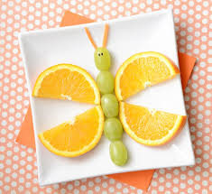[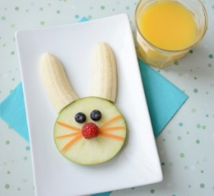](https://www.kixcereal.com/wp-content/uploads/2014/03/kixeasterbunny1.jpg)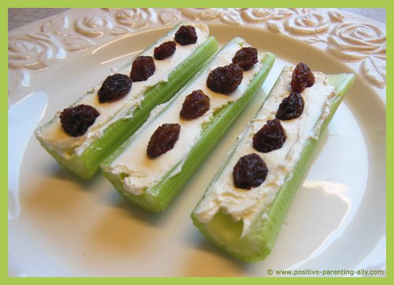

[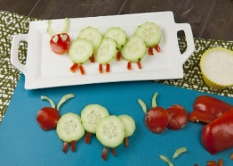](https://www.google.co.uk/url?sa=i&url=https%3A%2F%2Fwww.superhealthykids.com%2Frecipes%2Fcucumber-caterpillar-snack%2F&psig=AOvVaw1sR2yMY5bh6B9ZAIdzl0yl&ust=1585304242168000&source=images&cd=vfe&ved=0CAIQjRxqFwoTCNDJ_tP0t-gCFQAAAAAdAAAAABAE)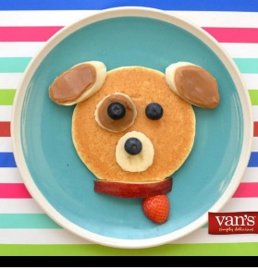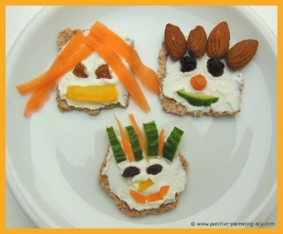

Banana Bread

|  |  |  |
| --- | --- | --- |
| 1.  Mix sugar and butter  C:\Users\Laverie1\AppData\Local\Microsoft\Windows\INetCache\Content.MSO\A4F072AE.tmp  1 ¼ cup sugar  C:\Users\Laverie1\AppData\Local\Microsoft\Windows\INetCache\Content.MSO\215D4DFD.tmp  ½ cup butter | 2.  C:\Users\Laverie1\AppData\Local\Microsoft\Windows\INetCache\Content.MSO\750DAB0F.tmpAdd eggs and milk  2 eggs  C:\Users\Laverie1\AppData\Local\Microsoft\Windows\INetCache\Content.MSO\C93BE872.tmp  ½ cup yogurt | 3.  C:\Users\Laverie1\AppData\Local\Microsoft\Windows\INetCache\Content.MSO\CCBE8B9C.tmpMash 3 ripe bananas. Add to the bowl  C:\Users\Laverie1\AppData\Local\Microsoft\Windows\INetCache\Content.MSO\2BB778F6.tmp    Add 1 teaspoon vanilla |
| 4.  Mix in dry ingredients  C:\Users\Laverie1\AppData\Local\Microsoft\Windows\INetCache\Content.MSO\654EE300.tmp  2 ½ cups flour  1 teaspoon baking soda  C:\Users\Laverie1\AppData\Local\Microsoft\Windows\INetCache\Content.MSO\D562483A.tmp  [Salt Clipart Images](https://www.google.co.uk/url?sa=i&url=https%3A%2F%2Fwww.clipart.email%2Fclipart%2Fsalt-clipart-images-73660.html&psig=AOvVaw11p9W5mcPh1n1xP3Mfjmgr&ust=1585393360902000&source=images&cd=vfe&ved=0CAIQjRxqFwoTCKDSsNbAuugCFQAAAAAdAAAAABAD)  1 teaspoon salt | C:\Users\Laverie1\AppData\Local\Microsoft\Windows\INetCache\Content.MSO\9756775F.tmp5.  Mix well  Pour batter into  C:\Users\Laverie1\AppData\Local\Microsoft\Windows\INetCache\Content.MSO\1FB846E1.tmpa greased loaf pan | 6.  Bake at 180 degrees c for 30 – 35 minutes  C:\Users\Laverie1\AppData\Local\Microsoft\Windows\INetCache\Content.MSO\AD2CD686.tmp |

Ava, age 2, makes banana bread

[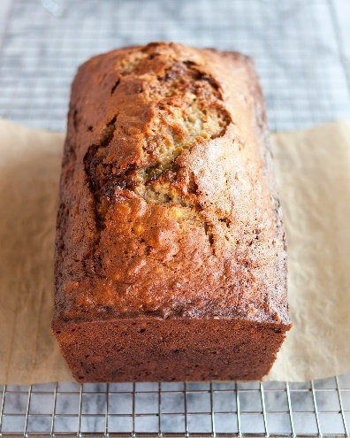](https://www.google.co.uk/url?sa=i&url=https%3A%2F%2Fwww.thekitchn.com%2Fhow-to-make-banana-bread-the-simplest-easiest-recipe-139900&psig=AOvVaw3mOxuZ5mDMvn1wfsYd3twk&ust=1585394738409000&source=images&cd=vfe&ved=0CAIQjRxqFwoTCMCO-uPFuugCFQAAAAAdAAAAABAd)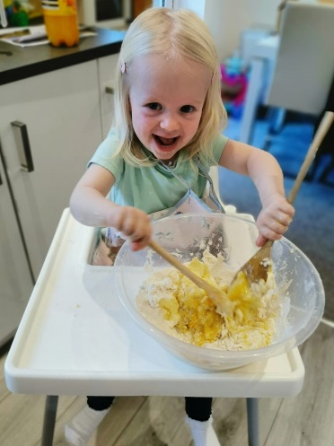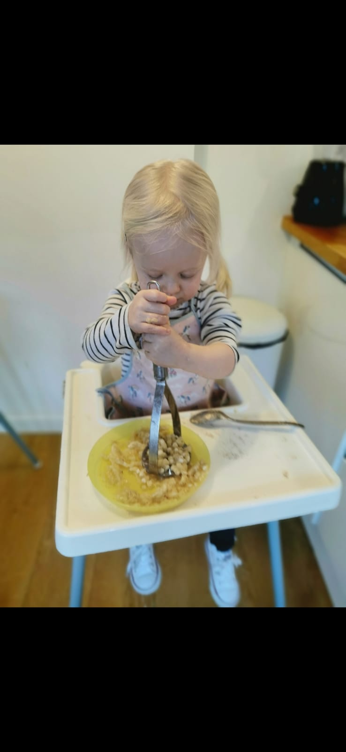

Mashing the banana Mixing the banana with the dry ingredients

Granola Bars

|  |  |  |
| --- | --- | --- |
| 1.  Measure and mix  C:\Users\Laverie1\AppData\Local\Microsoft\Windows\INetCache\Content.MSO\CBF1AD12.tmp  130g porridge oats  80g chopped nuts  C:\Users\Laverie1\AppData\Local\Microsoft\Windows\INetCache\Content.MSO\E3E03231.tmp | 2.  Toast the oats and nuts in the oven for 10 minutes, turning frequently  C:\Users\Laverie1\AppData\Local\Microsoft\Windows\INetCache\Content.MSO\AD2CD686.tmp | 3.  C:\Users\Laverie1\AppData\Local\Microsoft\Windows\INetCache\Content.MSO\AD8118A0.tmpMeasure and mix  50g brown sugar  C:\Users\Laverie1\AppData\Local\Microsoft\Windows\INetCache\Content.MSO\3DD35CA3.tmpC:\Users\Laverie1\AppData\Local\Microsoft\Windows\INetCache\Content.MSO\215D4DFD.tmp  50g unsalted butter  100g honey |
| 4.  Heat the honey, butter and sugar in a pot until the butter melts  C:\Users\Laverie1\AppData\Local\Microsoft\Windows\INetCache\Content.MSO\BBA63958.tmp | 5.  [Image result for chocolate chip bag cartoon](https://www.google.co.uk/url?sa=i&url=https%3A%2F%2Fwww.greenegrape.com%2F2010%2F02%2F15%2Fchocolate-chip-pancakes%2F&psig=AOvVaw1Irs5vBwZwMhM1AC03Tqc2&ust=1585324519275000&source=images&cd=vfe&ved=0CAIQjRxqFwoTCMCUxZjAuOgCFQAAAAAdAAAAABAJ)C:\Users\Laverie1\AppData\Local\Microsoft\Windows\INetCache\Content.MSO\897AF3E.tmpMix the toasted oats and nuts with the honey, butter and sugar.  Mix in 60g raisins or other dried fruit  Wait 5 minutes then add 1 table spoon of chocolate chips | 6.  C:\Users\Laverie1\AppData\Local\Microsoft\Windows\INetCache\Content.MSO\FC84819A.tmpC:\Users\Laverie1\AppData\Local\Microsoft\Windows\INetCache\Content.MSO\EF327D07.tmpC:\Users\Laverie1\AppData\Local\Microsoft\Windows\INetCache\Content.MSO\108853B5.tmpSpread mixture on a baking tray  Cut into bars and enjoy  Put the tray in the fridge for 2 hours |

Elliot, age 4, makes granola bars

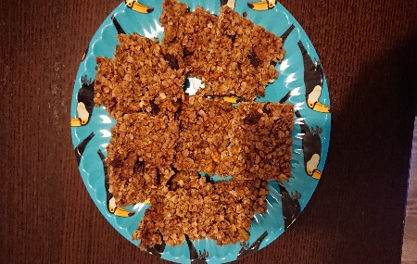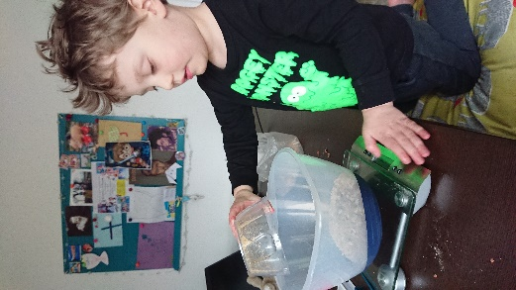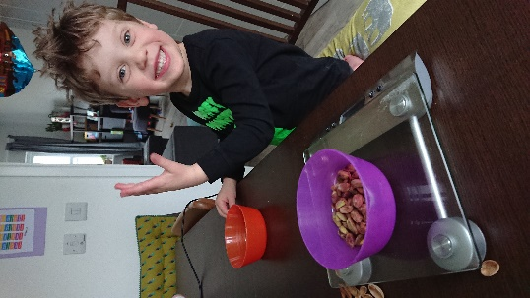

Smoothies

|  |  |  |
| --- | --- | --- |
| 1.  1 small ripe banana sliced  140g berries (blackberries, raspberries, strawberries)  Apple juice or water  C:\Users\Laverie1\AppData\Local\Microsoft\Windows\INetCache\Content.MSO\F2E1A79B.tmpC:\Users\Laverie1\AppData\Local\Microsoft\Windows\INetCache\Content.MSO\4557E2EA.tmp  C:\Users\Laverie1\AppData\Local\Microsoft\Windows\INetCache\Content.MSO\8D0FF8E9.tmp | 2.  Blend in a food processor or blender  C:\Users\Laverie1\AppData\Local\Microsoft\Windows\INetCache\Content.MSO\5675DEE.tmp | 3.  Toss a few extra fruit on top, drizzle with honey and serve  [Transparent Smoothies Clipart - Smoothie Cartoon Transparent, HD ...](https://www.google.co.uk/url?sa=i&url=https%3A%2F%2Fwww.pngitem.com%2Fmiddle%2FTmiJbT_transparent-smoothies-clipart-smoothie-cartoon-transparent-hd-png%2F&psig=AOvVaw1jYwdxSj7vLfO48X65TvjD&ust=1585653363453000&source=images&cd=vfe&ved=0CAIQjRxqFwoTCKDu6LyJwugCFQAAAAAdAAAAABAD) |

Dale 8 and Keir 4 make smoothies Maisie, age, 1 makes pancakes

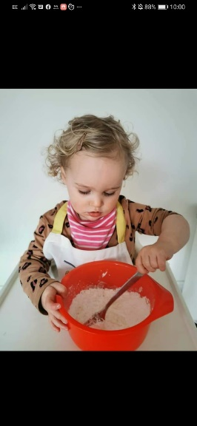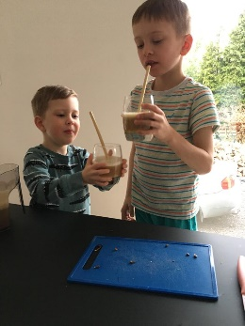**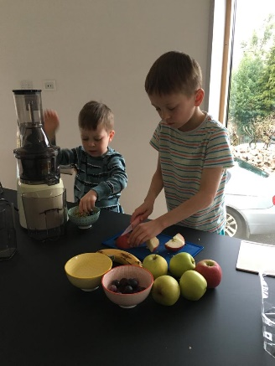**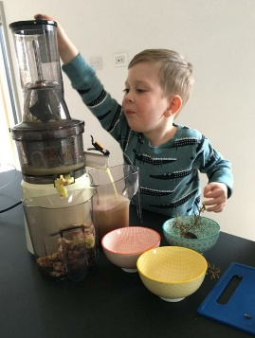

Dropped scone pancakes

|  |  |  |
| --- | --- | --- |
| 1.  Mix flour, sugar and egg  C:\Users\Laverie1\AppData\Local\Microsoft\Windows\INetCache\Content.MSO\654EE300.tmp  100g self-raising flour  C:\Users\Laverie1\AppData\Local\Microsoft\Windows\INetCache\Content.MSO\A4F072AE.tmp50g caster sugar  [Cracked Egg Clipart Images, Stock Photos & Vectors | Shutterstock](https://www.google.co.uk/url?sa=i&url=https%3A%2F%2Fwww.shutterstock.com%2Fsearch%2Fcracked%2Begg%2Bclipart&psig=AOvVaw0sPz05yGXk04uA1ad8WWv3&ust=1585655786373000&source=images&cd=vfe&ved=0CAIQjRxqFwoTCJi-4qSSwugCFQAAAAAdAAAAABAD)  1 egg | 2.  Gradually beat in milk to make a thick batter  [Milk Carton Clip Art - Royalty Free - GoGraph](https://www.google.co.uk/url?sa=i&url=https%3A%2F%2Fwww.gograph.com%2Fvector-clip-art%2Fmilk-carton.html&psig=AOvVaw0aoz0x9kl3tJIgCVTNohwT&ust=1585656159277000&source=images&cd=vfe&ved=0CAIQjRxqFwoTCPD56NaTwugCFQAAAAAdAAAAABAK)  C:\Users\Laverie1\AppData\Local\Microsoft\Windows\INetCache\Content.MSO\412FCB67.tmp60ml milk | 3.  [ᐈ Pancake stock illustrations, Royalty Free pancake cartoon ...](https://www.google.co.uk/url?sa=i&url=https%3A%2F%2Fdepositphotos.com%2Fvector-images%2Fpancake.html&psig=AOvVaw3_b5wNiwWd4n2KgDQFlpzC&ust=1585657988393000&source=images&cd=vfe&ved=0CAIQjRxqFwoTCJCnjsKawugCFQAAAAAdAAAAABAD)Bake by dropping spoonfuls of mixture onto a hot frying pan. Cook until the underside is golden brown. Turn and brown on the other side. |

Pizza

|  |  |  |
| --- | --- | --- |
| 1.  C:\Users\Laverie1\AppData\Local\Microsoft\Windows\INetCache\Content.MSO\654EE300.tmpMeasure and mix    350g Flour  C:\Users\Laverie1\AppData\Local\Microsoft\Windows\INetCache\Content.MSO\B8B5EEAF.tmp  2 ¾ teaspoons baking powder      C:\Users\Laverie1\AppData\Local\Microsoft\Windows\INetCache\Content.MSO\656F8492.tmp  1 tablespoon oil 1 teaspoon salt  [Salt Clipart Images](https://www.google.co.uk/url?sa=i&url=https%3A%2F%2Fwww.clipart.email%2Fclipart%2Fsalt-clipart-images-73660.html&psig=AOvVaw11p9W5mcPh1n1xP3Mfjmgr&ust=1585393360902000&source=images&cd=vfe&ved=0CAIQjRxqFwoTCKDSsNbAuugCFQAAAAAdAAAAABAD)  [measure%20clipart](http://www.clipartpanda.com/clipart_images/measuring-cup-clip-art-7861944)  170ml water | 2.  Mixture should be soft  [Cartoon wooden bowl with spoon isolated on white Vector Image](https://www.google.co.uk/url?sa=i&url=https%3A%2F%2Fwww.vectorstock.com%2Froyalty-free-vector%2Fcartoon-wooden-bowl-with-spoon-isolated-on-white-vector-24774972&psig=AOvVaw268xKeeF8F-sAGKP7CmDTB&ust=1585759038566000&source=images&cd=vfe&ved=0CAIQjRxqFwoTCKDm4viSxegCFQAAAAAdAAAAABAD)but not sticky  Knead on a floured surface for 3-4 minutes  C:\Users\Laverie1\AppData\Local\Microsoft\Windows\INetCache\Content.MSO\EE91EDC.tmp  [Free Pizza Crust Cliparts, Download Free Clip Art, Free Clip Art](https://www.clipart.email/make-a-clipart/?image=223729)  Roll into  2 balls  and flatten out | 3.  Make the pizza sauce. Mix the following ingredients in a pot and cook for 30 minutes  C:\Users\Laverie1\AppData\Local\Microsoft\Windows\INetCache\Content.MSO\E3DE91AA.tmp  400 g chopped tomatoes / passata  1 ½ tablespoon tomato puree  1 tablespoon dried oregano  1 teaspoon brown sugar  C:\Users\Laverie1\AppData\Local\Microsoft\Windows\INetCache\Content.MSO\303DA3B4.tmpC:\Users\Laverie1\AppData\Local\Microsoft\Windows\INetCache\Content.MSO\FCF61AEB.tmpC:\Users\Laverie1\AppData\Local\Microsoft\Windows\INetCache\Content.MSO\AD8118A0.tmp |
| [Pizza Clipart (Ideal For Fractions!) By HighFive_Clipart](https://www.clipart.email/make-a-clipart/?image=225316) 4.  Top your pizza  Smooth sauce  over pizza with a spoon  C:\Users\Laverie1\AppData\Local\Microsoft\Windows\INetCache\Content.MSO\5EC4FF5B.tmpScatter with cheese and other toppings  [Collection of Shredded clipart | Free download best Shredded ...](https://www.google.co.uk/imgres?imgurl=http%3A%2F%2Fclipartmag.com%2Fimages%2Fshredded-cheese-cliparts-47.png&imgrefurl=http%3A%2F%2Fclipartmag.com%2Ftag%2Fshredded&tbnid=F09QIwMQ2FqdJM&vet=12ahUKEwipnr7wyMXoAhVH2xoKHQbaC_oQMygVegQIARAt..i&docid=SdiSJ1DaTILGpM&w=326&h=241&q=grated%20cheese%20cartoon%20clip%20art&hl=en-GB&safe=strict&ved=2ahUKEwipnr7wyMXoAhVH2xoKHQbaC_oQMygVegQIARAt) | 5.  C:\Users\Laverie1\AppData\Local\Microsoft\Windows\INetCache\Content.MSO\AD2CD686.tmpPlace on a baking tray and Bake at 200 degrees c for 10 – 15 minutes | 6.  Serve and enjoy  C:\Users\Laverie1\AppData\Local\Microsoft\Windows\INetCache\Content.MSO\F7E6F0AE.tmp |

Cameron making her pizza dough

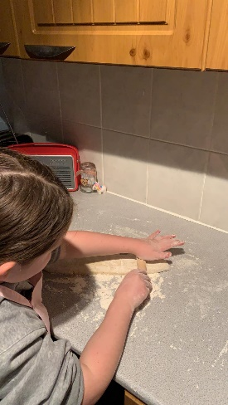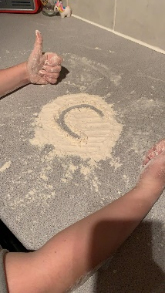

Fairy Cakes

|  |  |  |
| --- | --- | --- |
| 1.  Mix sugar and soft butter  C:\Users\Laverie1\AppData\Local\Microsoft\Windows\INetCache\Content.MSO\A4F072AE.tmp  100g caster sugar  C:\Users\Laverie1\AppData\Local\Microsoft\Windows\INetCache\Content.MSO\215D4DFD.tmp  100g very  soft butter | 2.  sift in the flour  100g self-raising flour  C:\Users\Laverie1\AppData\Local\Microsoft\Windows\INetCache\Content.MSO\4F6B40F8.tmpC:\Users\Laverie1\AppData\Local\Microsoft\Windows\INetCache\Content.MSO\654EE300.tmp | 3.  Break in eggs. Mix sugar, butter, flour, eggs and vanilla together.  C:\Users\Laverie1\AppData\Local\Microsoft\Windows\INetCache\Content.MSO\750DAB0F.tmp  2 eggs  C:\Users\Laverie1\AppData\Local\Microsoft\Windows\INetCache\Content.MSO\2BB778F6.tmp    Add 1 teaspoon vanilla |
| 4.  [An Easy Cupcake Recipe - How To Make Cupcakes - Liana's Kitchen](https://www.google.co.uk/url?sa=i&url=https%3A%2F%2Fwww.lianaskitchen.co.uk%2Fcupcake-recipe%2F&psig=AOvVaw1yZ7B-nuZWNv-wc0eMAmNL&ust=1585660641203000&source=images&cd=vfe&ved=0CAIQjRxqFwoTCNDUqLmkwugCFQAAAAAdAAAAABAD)Divide between cases and bake at 180 degrees c for 20 minutes  C:\Users\Laverie1\AppData\Local\Microsoft\Windows\INetCache\Content.MSO\AD2CD686.tmp | 5.  C:\Users\Laverie1\AppData\Local\Microsoft\Windows\INetCache\Content.MSO\215D4DFD.tmpFor the icing. Mix butter and sugar  200g very  soft butter  [Icing Sugar Clipart](https://www.google.co.uk/url?sa=i&url=https%3A%2F%2Fwww.clipart.email%2Fclipart%2Ficing-sugar-clipart-326732.html&psig=AOvVaw1QrzPEO5RRnyXYYEJn6nzJ&ust=1585661012425000&source=images&cd=vfe&ved=0CAIQjRxqFwoTCKChwO2lwugCFQAAAAAdAAAAABAQ)  200g icing  sugar | 6.  **C:\Users\Laverie1\AppData\Local\Microsoft\Windows\INetCache\Content.MSO\755E1B00.tmp**Let cakes cool. Spoon or pipe icing onto each cake and decorate with sprinkles, or whatever you like. |

Everyone loves making Fairy Cakes

Grayson, 2 Lilly, 3 Lachlan, 3 and Eilidh, 1

**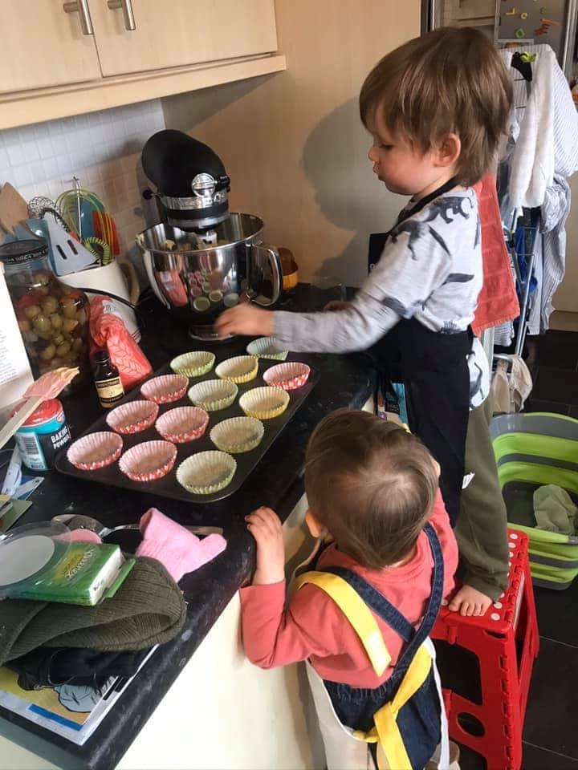**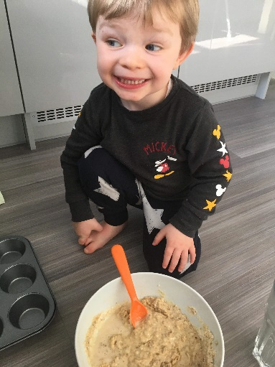**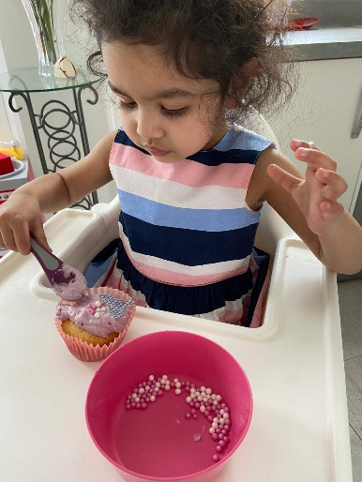**

|  |  |  |  |  |
| --- | --- | --- | --- | --- |
| Snack |  | Ingredients | | |
| [Image result for fruit and yogurt tortilla](https://www.google.co.uk/url?sa=i&url=https%3A%2F%2Fwww.superhealthykids.com%2Frecipes%2Fhealthy-fruit-pizza-minis%2F&psig=AOvVaw3w5T9xe4is7CpugKr8PID1&ust=1585330552732000&source=images&cd=vfe&ved=0CAIQjRxqFwoTCKD1vtXWuOgCFQAAAAAdAAAAABAE)  Fruit Pizza |  | [Taco Cartoon](https://www.kissclipart.com/tortilla-vector-png-clipart-spanish-omelette-taco-v85fxd/download-clipart.html)  Tortilla | C:\Users\Laverie1\AppData\Local\Microsoft\Windows\INetCache\Content.MSO\F0AEF78F.tmp  Yogurt | C:\Users\Laverie1\AppData\Local\Microsoft\Windows\INetCache\Content.MSO\3AACDFA1.tmp  Fruit |
| [Image result for kids tortilla snack](https://www.google.co.uk/url?sa=i&url=https%3A%2F%2Fwww.positive-parenting-ally.com%2Feasy-snacks-for-kids.html&psig=AOvVaw0zJ6AE9mbtRwLoAqJR1iyT&ust=1585331908369000&source=images&cd=vfe&ved=0CAIQjRxqFwoTCJDR7tvbuOgCFQAAAAAdAAAAABAb)  Fruit tacco |  | C:\Users\Laverie1\AppData\Local\Microsoft\Windows\INetCache\Content.MSO\F592025E.tmp  Taco | C:\Users\Laverie1\AppData\Local\Microsoft\Windows\INetCache\Content.MSO\A832CF6D.tmp  Grapes | C:\Users\Laverie1\AppData\Local\Microsoft\Windows\INetCache\Content.MSO\A213BF28.tmp  Apples |
| C:\Users\Laverie1\AppData\Local\Microsoft\Windows\INetCache\Content.MSO\CAF94FF.tmp  Boiled egg sail boats |  | C:\Users\Laverie1\AppData\Local\Microsoft\Windows\INetCache\Content.MSO\230C7122.tmp  Boiled eggs | C:\Users\Laverie1\AppData\Local\Microsoft\Windows\INetCache\Content.MSO\7AACEF81.tmp  Cheese triangels for sails | C:\Users\Laverie1\AppData\Local\Microsoft\Windows\INetCache\Content.MSO\CC413EBA.tmp  Or peppers for sails |
| [Image result for kids easy snacks](https://www.google.co.uk/url?sa=i&url=https%3A%2F%2Fwww.delish.com%2Fcooking%2Fg1147%2Fquick-kids-snacks%2F&psig=AOvVaw2bX-ecEKwZFjs2DLKD8ePP&ust=1585335129057000&source=images&cd=vfe&ved=0CAIQjRxqFwoTCODZqN3nuOgCFQAAAAAdAAAAABAD)  Pizza toast |  | C:\Users\Laverie1\AppData\Local\Microsoft\Windows\INetCache\Content.MSO\A92D4E6F.tmp  C:\Users\Laverie1\AppData\Local\Microsoft\Windows\INetCache\Content.MSO\D2571E3.tmp  Tomato paste and bread | C:\Users\Laverie1\AppData\Local\Microsoft\Windows\INetCache\Content.MSO\7AACEF81.tmp  Gratted cheese | C:\Users\Laverie1\AppData\Local\Microsoft\Windows\INetCache\Content.MSO\7481632B.tmp  Pepperoni or vegetables |
| [Image result for apple burgers kids snacks](https://www.google.co.uk/url?sa=i&url=https%3A%2F%2Fboulderlocavore.com%2Fapple-peanut-butter-sandwiches%2F&psig=AOvVaw2jQK_h5QB8P0XFW8bpqxJy&ust=1585336127653000&source=images&cd=vfe&ved=0CAIQjRxqFwoTCJjbg8TruOgCFQAAAAAdAAAAABAD)  Apple Sandwich |  | C:\Users\Laverie1\AppData\Local\Microsoft\Windows\INetCache\Content.MSO\A213BF28.tmp  Apples | C:\Users\Laverie1\AppData\Local\Microsoft\Windows\INetCache\Content.MSO\D1DF23DF.tmp  Peanut Butter | C:\Users\Laverie1\AppData\Local\Microsoft\Windows\INetCache\Content.MSO\A12F5982.tmp  Banana or other fruit |

Healthy Snack Ideas